**Assessment-2 Week -2**

**2)Identify the following Cloud Services types and list their characteristics and advantages**

Cloud Computing can be defined as the practice of using a network of remote servers hosted on the Internet to store, manage, and process data, rather than a local server or a personal computer. Companies offering such kinds of [cloud computing](https://www.geeksforgeeks.org/architecture-of-cloud-computing/) services are called [*cloud providers*](https://www.geeksforgeeks.org/top-5-cloud-platform-service-providers-in-2020/) and typically charge for cloud computing services based on usage. Grids and clusters are the foundations for cloud computing.

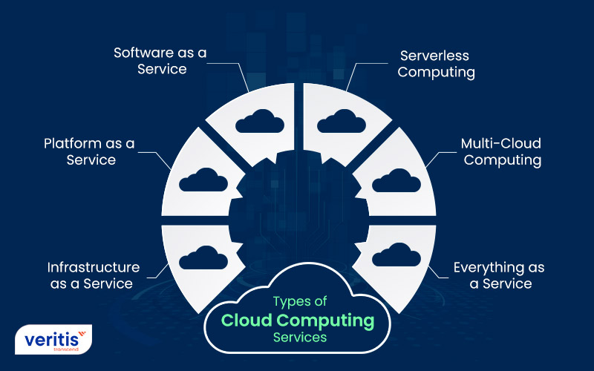

**Types of Cloud Computing**

Most cloud computing services fall into five broad categories:

1. Software as a service (SaaS)
2. Platform as a service (PaaS)
3. Infrastructure as a service (IaaS)
4. Anything/Everything as a service (XaaS)
5. Function as a Service (FaaS)

These are sometimes called the **cloud computing stack** because they are built on top of one another. Knowing what they are and how they are different, makes it easier to accomplish your goals. These abstraction layers can also be viewed as a **layered architecture** where services of a higher layer can be composed of services of the underlying layer i.e, SaaS can provide Infrastructure.

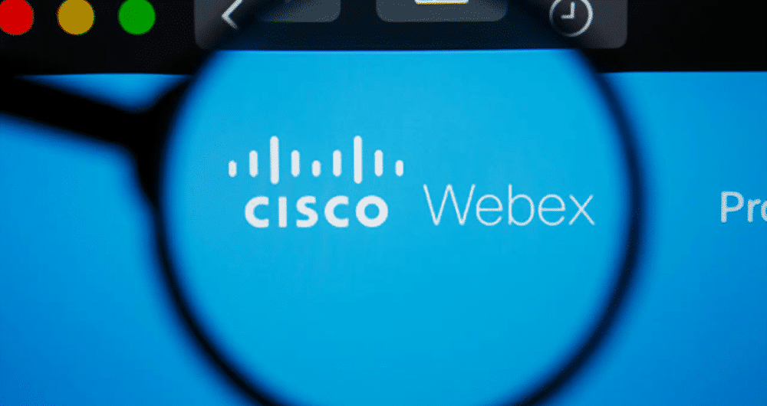

**Webex Meetings Features**

20 million reliable video conferences a month.

Free video calls and screen sharing with Webex.

Screen share — free.

Webex webinars are delivered reliably.

Easily present online.

Collaborate with your team.

Get more from your conference call.

**Software as a Service(SaaS)**

[Software-as-a-Service (SaaS)](https://www.geeksforgeeks.org/software-as-a-service-saas/) is a way of delivering services and applications over the Internet. Instead of installing and maintaining software, we simply access it via the Internet, freeing ourselves from the complex software and hardware management. It removes the need to install and run applications on our own computers or in the data centers eliminating the expenses of hardware as well as software maintenance.   
SaaS provides a complete software solution that you purchase on a **pay-as-you-go** basis from a cloud service provider. Most SaaS applications can be run directly from a web browser without any downloads or installations required. The SaaS applications are sometimes called **Web-based software, on-demand software, or hosted software.**

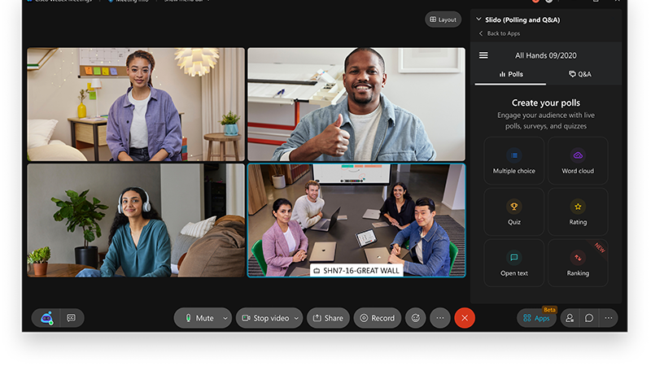

**Advantages of SaaS**

1. **Cost-Effective:** Pay only for what you use.
2. **Reduced time:** Users can run most SaaS apps directly from their web browser without needing to download and install any software. This reduces the time spent in installation and configuration and can reduce the issues that can get in the way of the software deployment.
3. **Accessibility:** We can Access app data from anywhere.
4. **Automatic updates:** Rather than purchasing new software, customers rely on a SaaS provider to automatically perform the updates.
5. **Scalability:**It allows the users to access the services and features on-demand.

The various companies providing *Software as a service* are Cloud9 Analytics, Salesforce.com, Cloud Switch, Microsoft Office 365, Big Commerce, Eloqua, dropBox, and Cloud Tran.

**Disadvantages of Saas :**

1. **Limited customization**: SaaS solutions are typically not as customizable as on-premises software, meaning that users may have to work within the constraints of the SaaS provider’s platform and may not be able to tailor the software to their specific needs.
2. **Dependence on internet connectivity**: SaaS solutions are typically cloud-based, which means that they require a stable internet connection to function properly. This can be problematic for users in areas with poor connectivity or for those who need to access the software in offline environments.
3. **Security concerns:** SaaS providers are responsible for maintaining the security of the data stored on their servers, but there is still a risk of data breaches or other security incidents.
4. **Limited control over data:** SaaS providers may have access to a user’s data, which can be a concern for organizations that need to maintain strict control over their data for regulatory or other reasons.

**Platform as a Service**

[PaaS](https://www.geeksforgeeks.org/platform-as-a-service-paas-and-its-types/) is a category of cloud computing that provides a platform and environment to allow developers to build applications and services over the internet. PaaS services are hosted in the cloud and accessed by users simply via their web browser.   
A PaaS provider hosts the hardware and software on its own infrastructure. As a result, PaaS frees users from having to install in-house hardware and software to develop or run a new application. Thus, the development and deployment of the application take place **independent of the hardware**.   
The consumer does not manage or control the underlying cloud infrastructure including network, servers, operating systems, or storage, but has control over the deployed applications and possibly configuration settings for the application-hosting environment. To make it simple, take the example of an annual day function, you will have two options either to create a venue or to rent a venue but the function is the same.

**Advantages of PaaS:**

1. **Simple and convenient for users:**It provides much of the infrastructure and other IT services, which users can access anywhere via a web browser.
2. **Cost-Effective:**It charges for the services provided on a per-use basis thus eliminating the expenses one may have for on-premises hardware and software.
3. **Efficiently managing the lifecycle:** It is designed to support the complete web application lifecycle: building, testing, deploying, managing, and updating.
4. **Efficiency:** It allows for higher-level programming with reduced complexity thus, the overall development of the application can be more effective.

The various companies providing *Platform as a service* are Amazon Web services Elastic Beanstalk, Salesforce, Windows Azure, Google App Engine, cloud Bees and IBM smart cloud.

**Disadvantages of Paas:**

1. **Limited control over infrastructure:** PaaS providers typically manage the underlying infrastructure and take care of maintenance and updates, but this can also mean that users have less control over the environment and may not be able to make certain customizations.
2. **Dependence on the provider**: Users are dependent on the PaaS provider for the availability, scalability, and reliability of the platform, which can be a risk if the provider experiences outages or other issues.
3. **Limited flexibility:** PaaS solutions may not be able to accommodate certain types of workloads or applications, which can limit the value of the solution for certain organizations.

**Google app engine**

App Engine is a fully managed, serverless platform for developing and hosting web applications at scale. You can choose from several popular languages, libraries, and frameworks to develop your apps, and then let App Engine take care of provisioning servers and scaling your app instances based on demand.

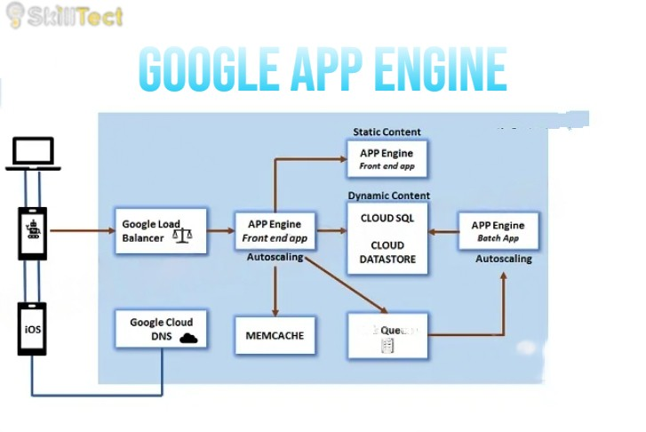

A scalable runtime environment, Google App Engine is mostly used to run Web applications. These dynamic scales as demand change over time because of Google’s vast computing infrastructure. Because it offers a secure execution environment in addition to a number of services, App Engine makes it easier to develop scalable and high-performance Web apps. Google’s applications will scale up and down in response to shifting demand. Croon tasks, communications, scalable data stores, work queues, and in-memory caching are some of these services.

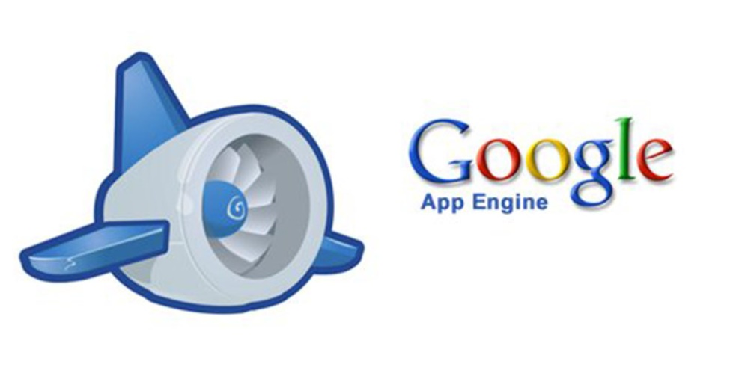

The App Engine SDK facilitates the testing and professionalization of applications by emulating the production runtime environment and allowing developers to design and test applications on their own PCs. When an application is finished being produced, developers can quickly migrate it to App Engine, put in place quotas to control the cost that is generated, and make the programmer available to everyone. Python, Java, and Go are among the languages that are currently supported.

**Infrastructure as a Service**

Infrastructure as a service (IaaS) is a service model that delivers computer infrastructure on an outsourced basis to support various operations. Typically IaaS is a service where infrastructure is provided as outsourcing to enterprises such as networking equipment, devices, database, and web servers.   
It is also known as **Hardware as a Service (HaaS).** IaaS customers pay on a per-user basis, typically by the hour, week, or month. Some providers also charge customers based on the amount of virtual machine space they use.   
It simply provides the underlying operating systems, security, networking, and servers for developing such applications, and services, and deploying development tools, databases, etc.

**Advantages of IaaS:**

1. **Cost-Effective:** Eliminates capital expense and reduces ongoing cost and IaaS customers pay on a per-user basis, typically by the hour, week, or month.
2. **Website hosting:** Running websites using IaaS can be less expensive than traditional web hosting.
3. **Security:**The IaaS Cloud Provider may provide better security than your existing software.
4. **Maintenance:** There is no need to manage the underlying data center or the introduction of new releases of the development or underlying software. This is all handled by the IaaS Cloud Provider.

The various companies providing *Infrastructure as a service* are [Amazon web services](https://www.geeksforgeeks.org/amazon-web-services-setting-up-an-aws-account/), Bluestack, IBM, Openstack, Rackspace, and Vmware.

**Disadvantages of laaS :**

1. **Limited control over infrastructure:**IaaS providers typically manage the underlying infrastructure and take care of maintenance and updates, but this can also mean that users have less control over the environment and may not be able to make certain customizations.
2. **Security concerns**: Users are responsible for securing their own data and applications, which can be a significant undertaking.
3. **Limited access:**Cloud computing may not be accessible in certain regions and countries due to legal policies.

**Anything as a Service**

It is also known as Everything as a Service. Most of the cloud service providers nowadays offer anything as a service that is a compilation of all of the above services including some additional services.

**Advantages of XaaS:**

1. **Scalability:** XaaS solutions can be easily scaled up or down to meet the changing needs of an organization.
2. **Flexibility:** XaaS solutions can be used to provide a wide range of services, such as storage, databases, networking, and software, which can be customized to meet the specific needs of an organization.
3. **Cost-effectiveness**: XaaS solutions can be more cost-effective than traditional on-premises solutions, as organizations only pay for the services.

**Disadvantages of XaaS:**

1. **Dependence on the provider:**Users are dependent on the XaaS provider for the availability, scalability, and reliability of the service, which can be a risk if the provider experiences outages or other issues.
2. **Limited flexibility**: XaaS solutions may not be able to accommodate certain types of workloads or applications, which can limit the value of the solution for certain organizations.
3. **Limited integration:** XaaS solutions may not be able to integrate with existing systems and data sources, which can limit the value of the solution for certain organizations.

**Function as a Service :**

FaaS is a type of cloud computing service. It provides a platform for its users or customers to develop, compute, run and deploy the code or entire application as functions. It allows the user to entirely develop the code and update it at any time without worrying about the maintenance of the underlying infrastructure. The developed code can be executed with response to the specific event. It is also **as same as PaaS**.

FaaS is an event-driven execution model. It is implemented in the serverless container. When the application is developed completely, the user will now trigger the event to execute the code. Now, the triggered event makes response and activates the servers to execute it. The servers are nothing but the Linux servers or any other servers which is managed by the vendor completely. Customer does not have clue about any servers which is why they do not need to maintain the server hence it is **serverless architecture.**

Both PaaS and FaaS are providing the same functionality but there is still some differentiation in terms of Scalability and Cost.

FaaS, provides auto-scaling up and scaling down depending upon the demand. PaaS also provides scalability but here users have to configure the scaling parameter depending upon the demand.

In FaaS, users only have to pay for the number of execution time happened. In PaaS, users have to pay for the amount based on pay-as-you-go price regardless of how much or less they use.

**Advantages of FaaS :**

* **Highly Scalable:**Auto scaling is done by the provider depending upon the demand.
* **Cost-Effective:**Pay only for the number of events executed.
* **Code Simplification:**FaaS allows the users to upload the entire application all at once. It allows you to write code for independent functions or similar to those functions.
* Maintenance of code is enough and no need to worry about the servers.
* Functions can be written in any programming language.
* Less control over the system.

The various companies providing Function as a Service are Amazon Web Services – Firecracker, Google – Kubernetes, Oracle – Fn, Apache OpenWhisk – IBM, OpenFaaS,

**Disadvantages of FaaS :**

1. **Cold start latency**: Since FaaS functions are event-triggered, the first request to a new function may experience increased latency as the function container is created and initialized.
2. **Limited control over infrastructure:** FaaS providers typically manage the underlying infrastructure and take care of maintenance and updates, but this can also mean that users have less control over the environment and may not be able to make certain customizations.
3. **Security concerns:**Users are responsible for securing their own data and applications, which can be a significant undertaking.
4. **Limited scalability**: FaaS functions may not be able to handle high traffic or large number of requests.

**Amazon**

Amazon Web Service EC2 (Amazon Elastic Compute Cloud), one of Amazon Web Services' most well-known services, offers businesses the ability to run applications on the public cloud. An EC2 instance is simply a virtual server in Amazon Web Services terminology.

## What is Amazon EC2 (Elastic Compute Cloud)?

[Amazon Web service](https://www.geeksforgeeks.org/introduction-to-amazon-web-services/) offers EC2 which is a short form of Elastic Compute Cloud (ECC) it is a cloud computing service offered by the Cloud Service Provider AWS. You can deploy your applications in EC2 servers without any worrying about the underlying infrastructure. You configure the EC2-Instance in a very secure manner by using the VPC, [Subnets,](https://www.geeksforgeeks.org/amazon-vpc-introduction-to-amazon-virtual-cloud/)and [Security groups.](https://www.geeksforgeeks.org/what-is-security-group-in-aws-and-how-to-create-it/) You can scale the configuration of the EC2 instance you have configured based on the demand of the application by attaching the autoscaling group to the EC2 instance. You can scale up and scale down the instance based on the incoming traffic of the application.

`